**CONTENTS**

TRAINING 3 1

A – 03.TSP 1

B – 03. KNAPSAC 2

C – 03.BCA 2

D – 03.CBUS 3

E – 03.BACP 3

F – 03.TAXI 4

G – 03.CVRPCOUNT 4

H – 03. CVRP OPT 5

M – DIGITS 5

N – PERMUTATIONGEN 6

O – PERMUTATIONLIST 6

R – BINARYGEN 7

T – HOLLEY N QUEENS 7

U – 05.NURSE 8

V – KPATH 8

W – ROUTING 9

X – CNK RM 9

KẾT QUẢ TRAINING 3 10

# **TRAINING 3**

## **A – 03.TSP**

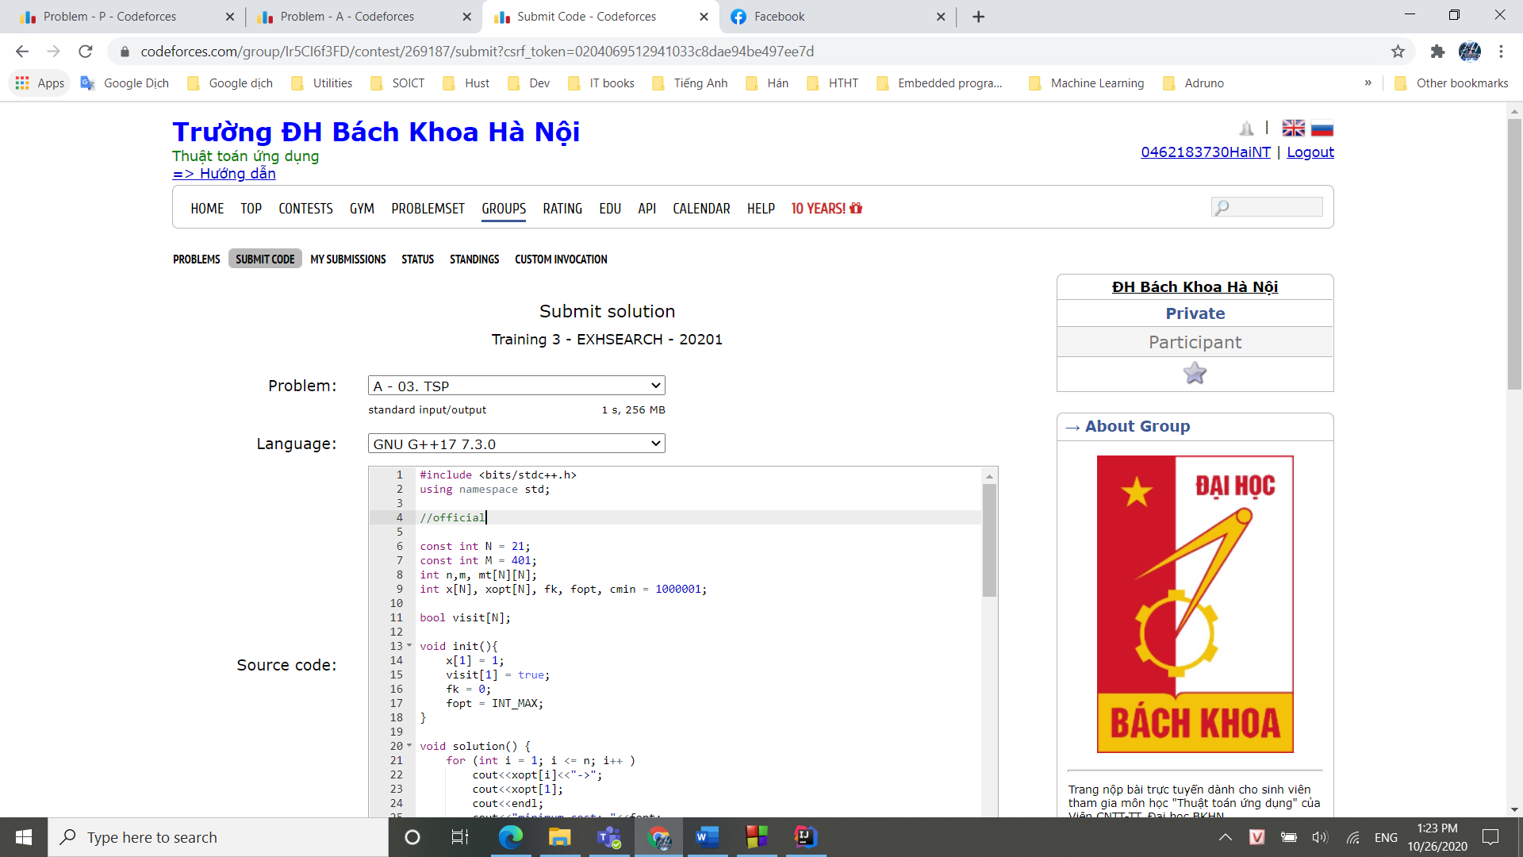

## **B – 03. KNAPSAC**

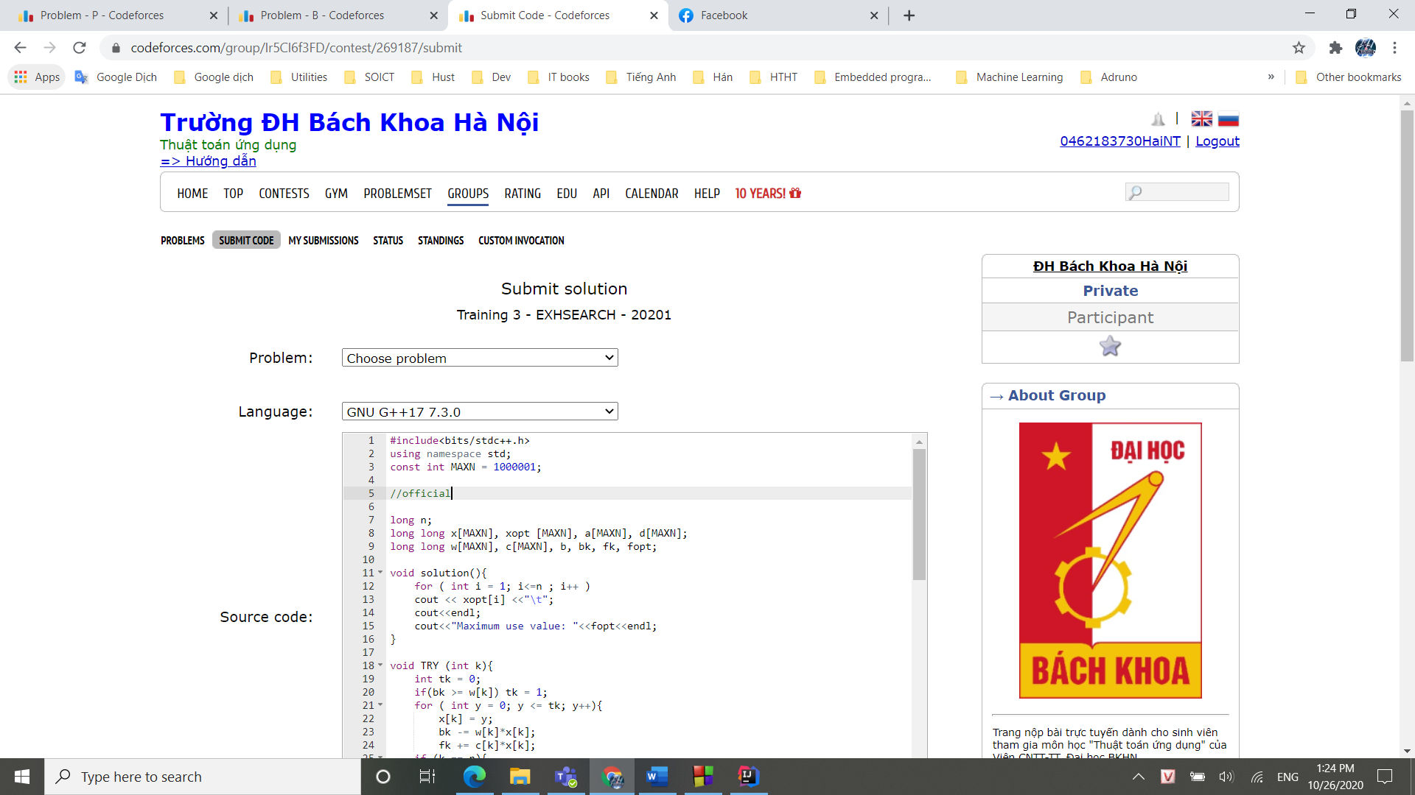

## **C – 03.BCA**

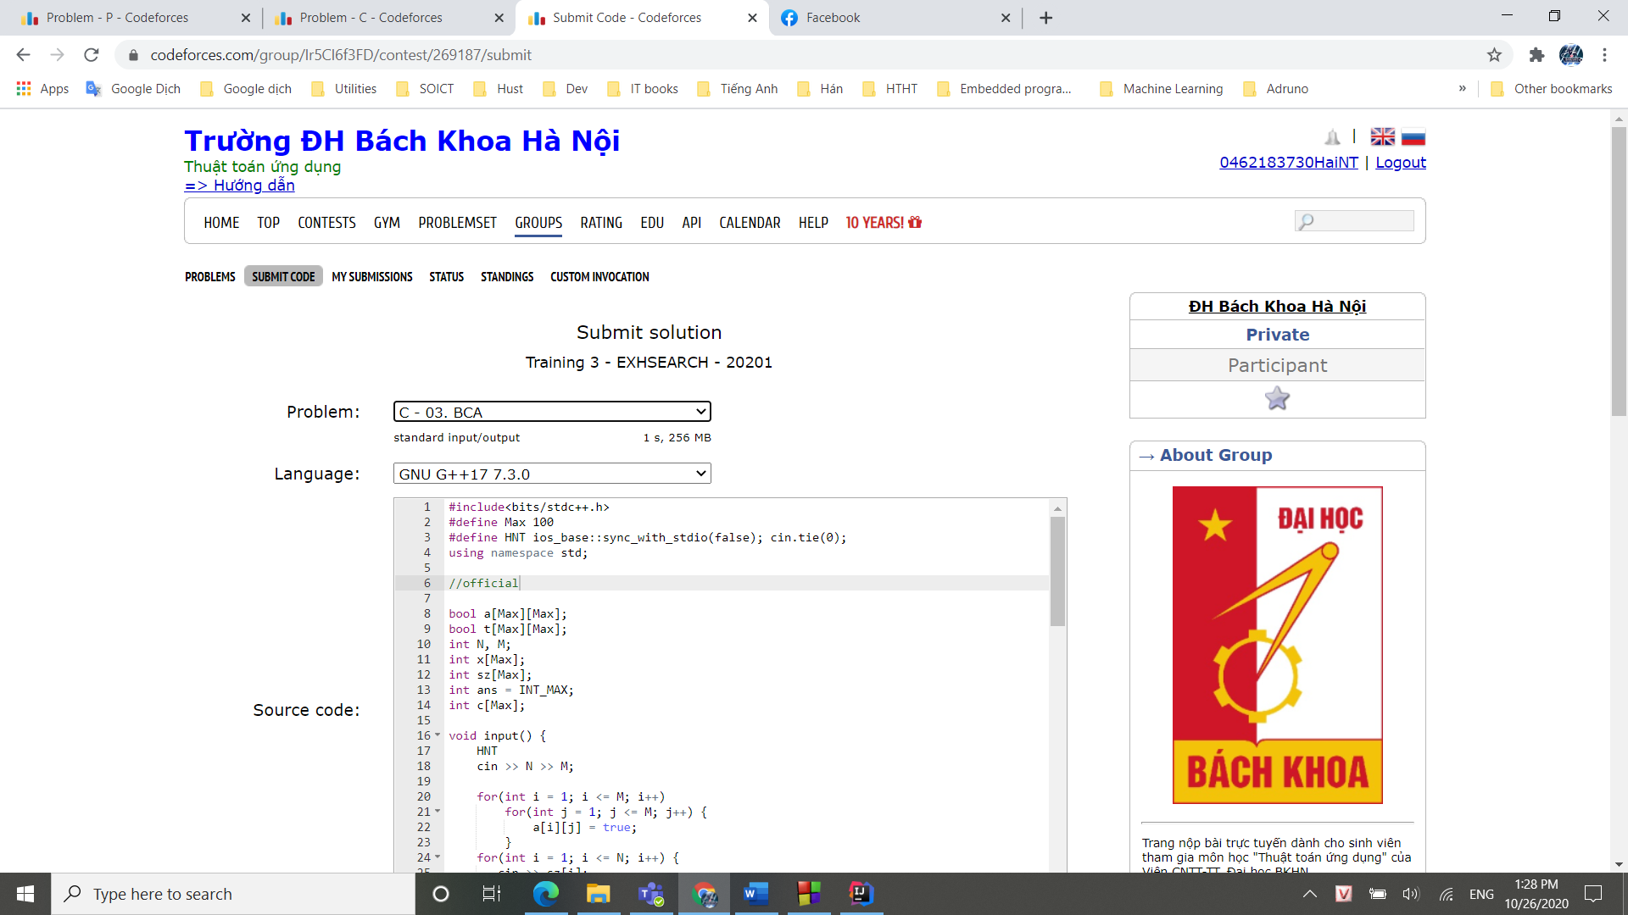

## **D – 03.CBUS**

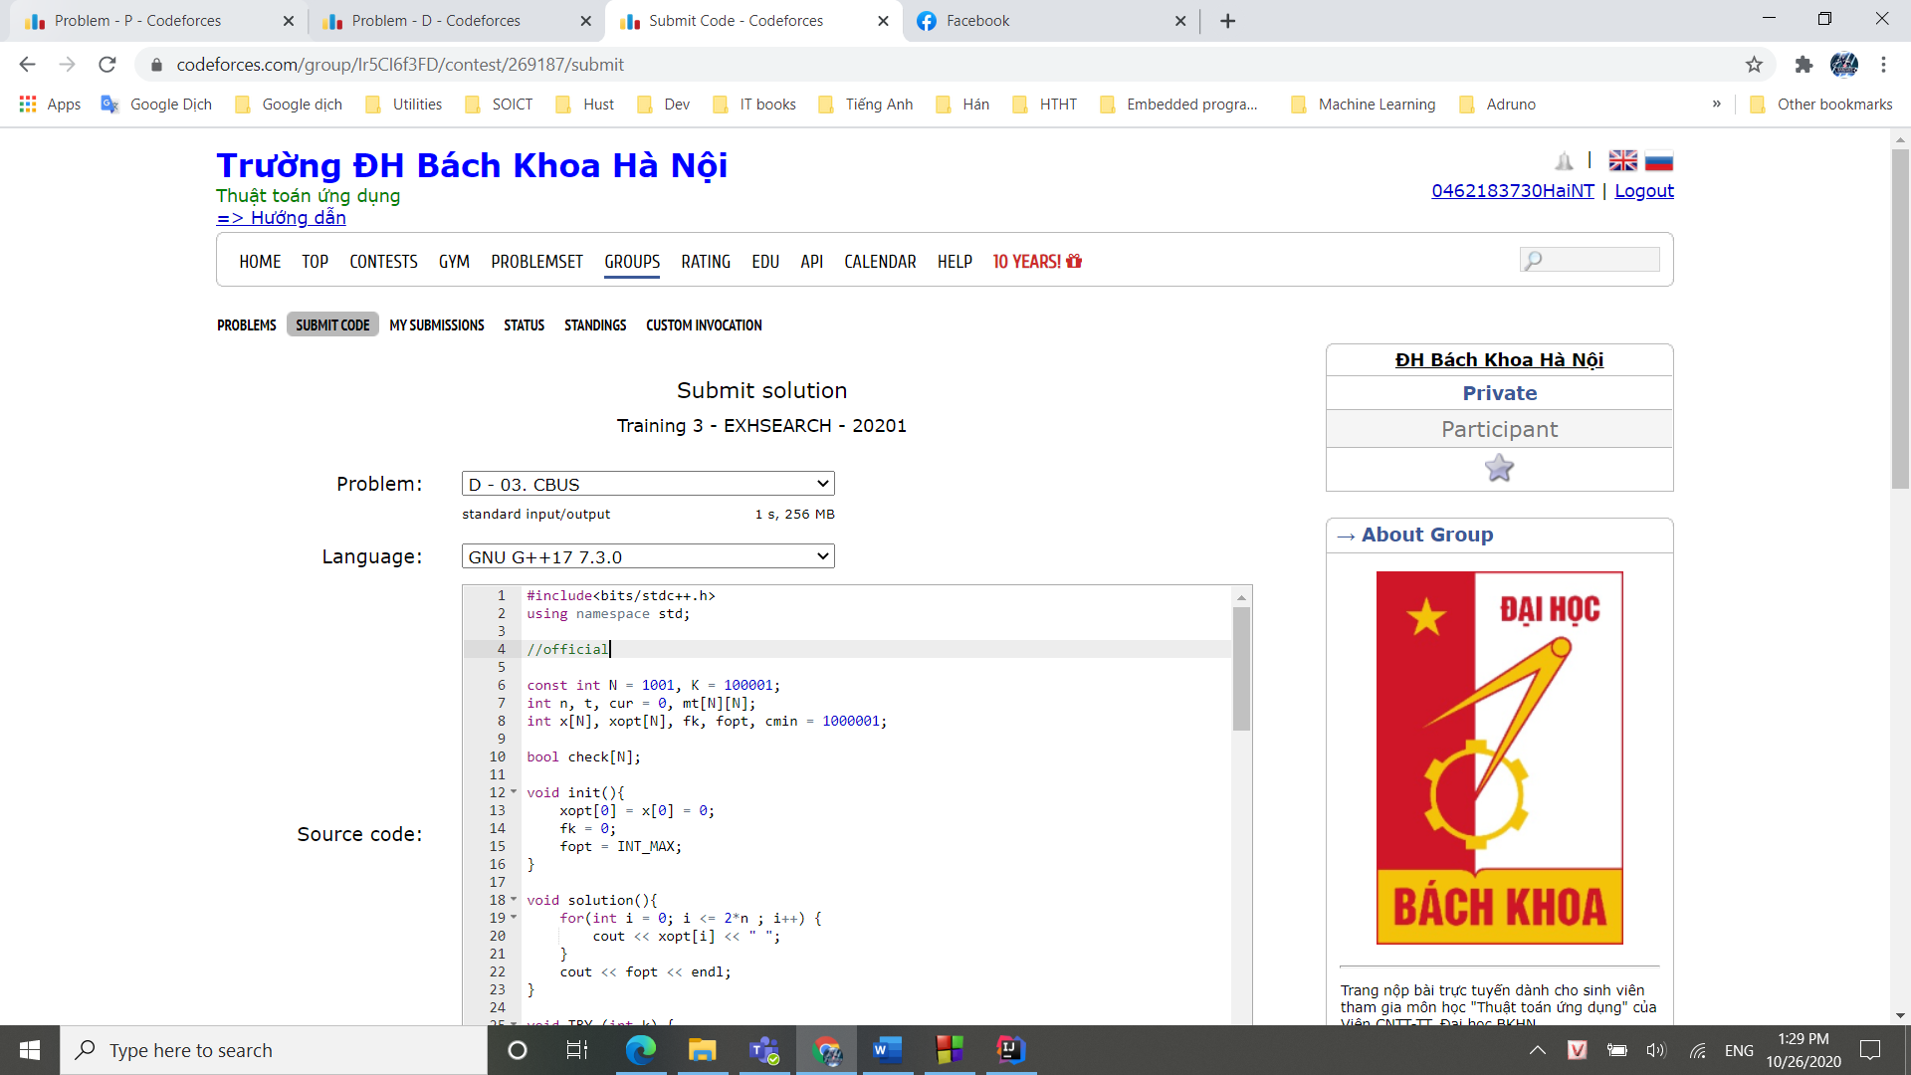

## **E – 03.BACP**

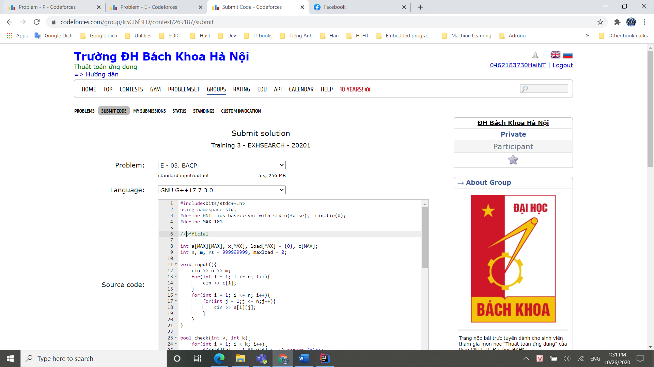

## **F – 03.TAXI**

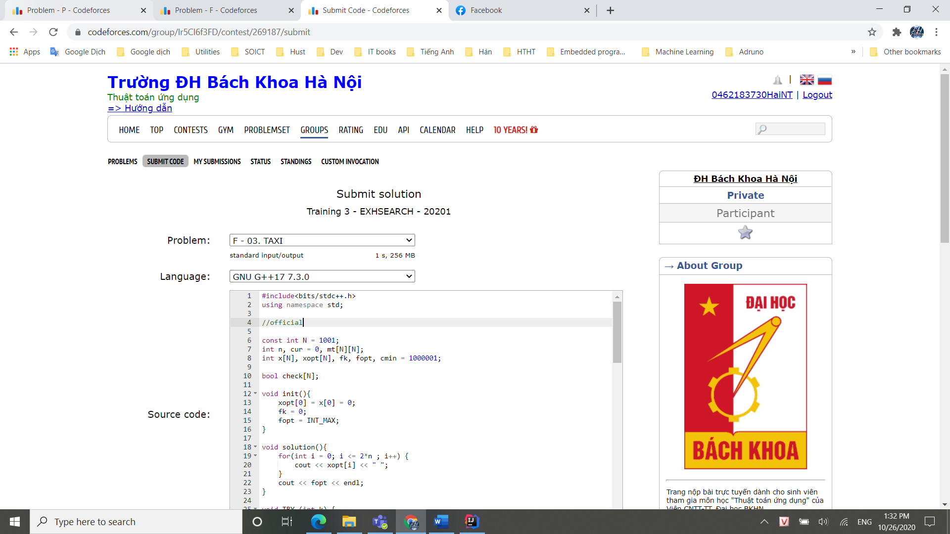

## **G – 03.CVRPCOUNT**

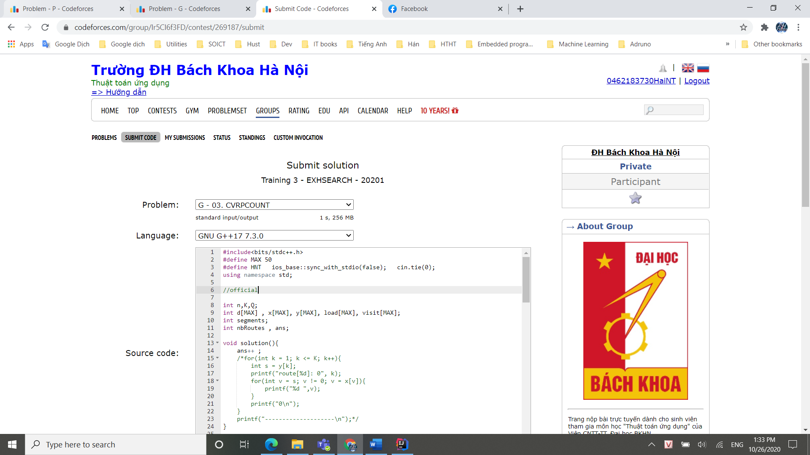

## **H – 03. CVRP OPT**

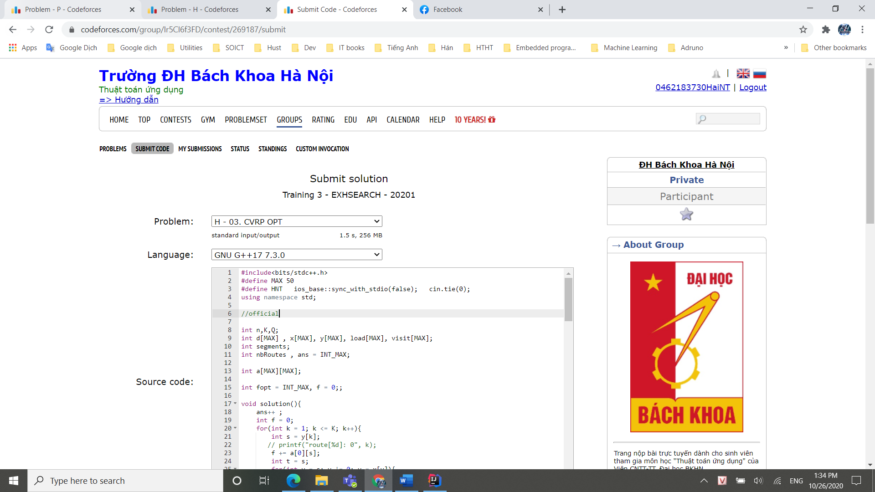

## **M – DIGITS**

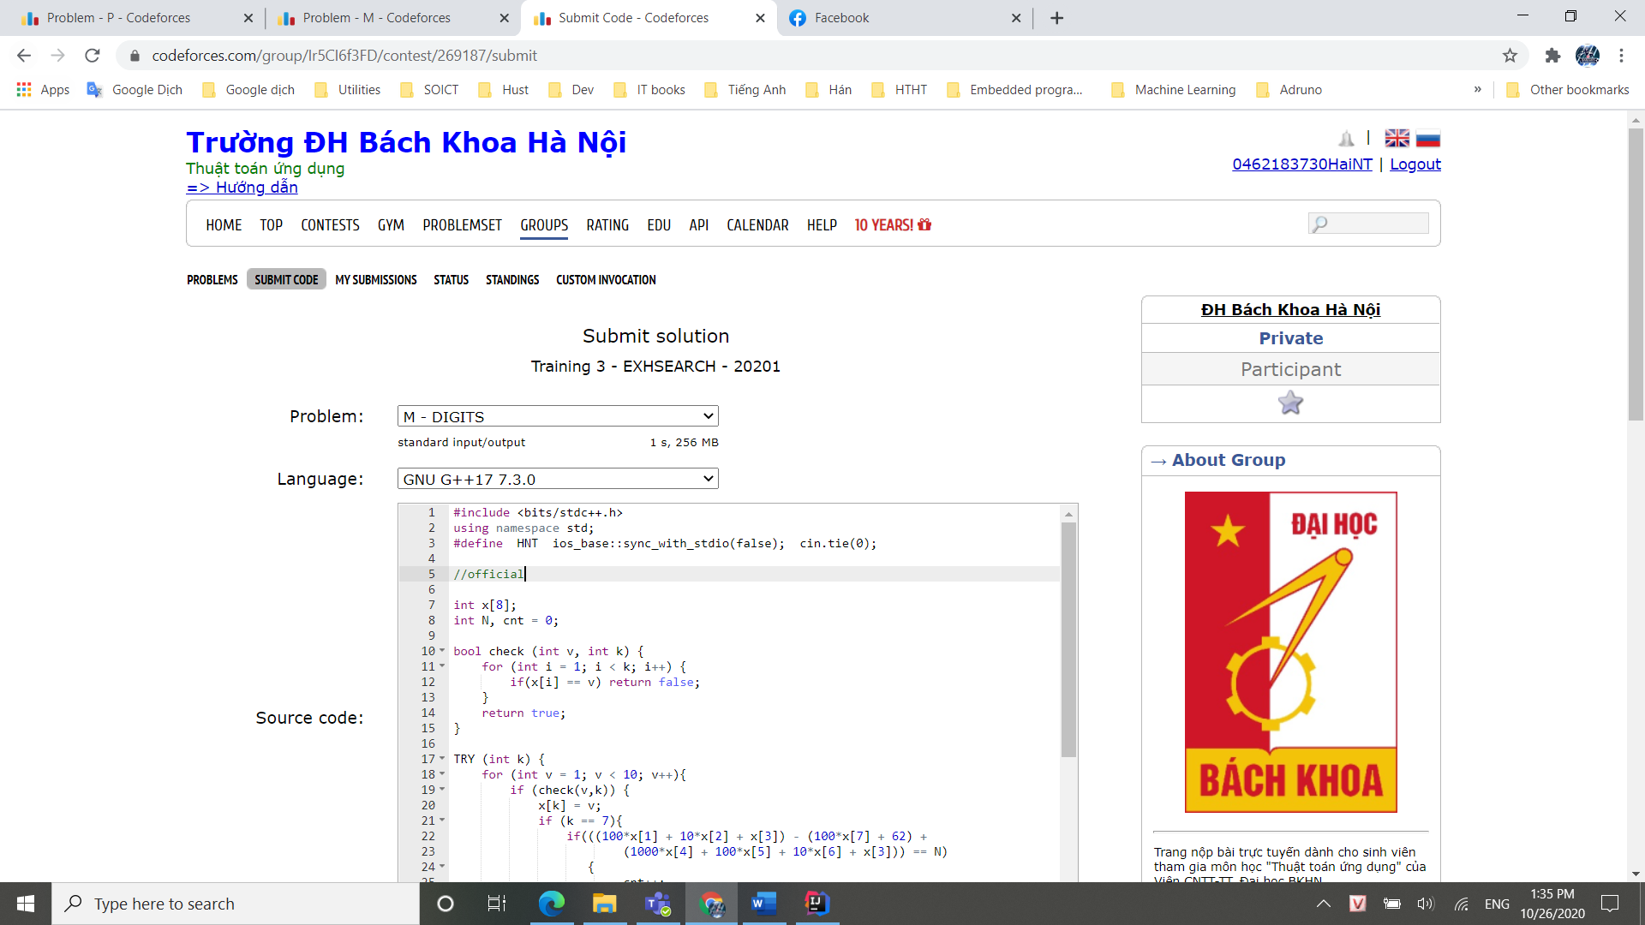

## **N – PERMUTATIONGEN**

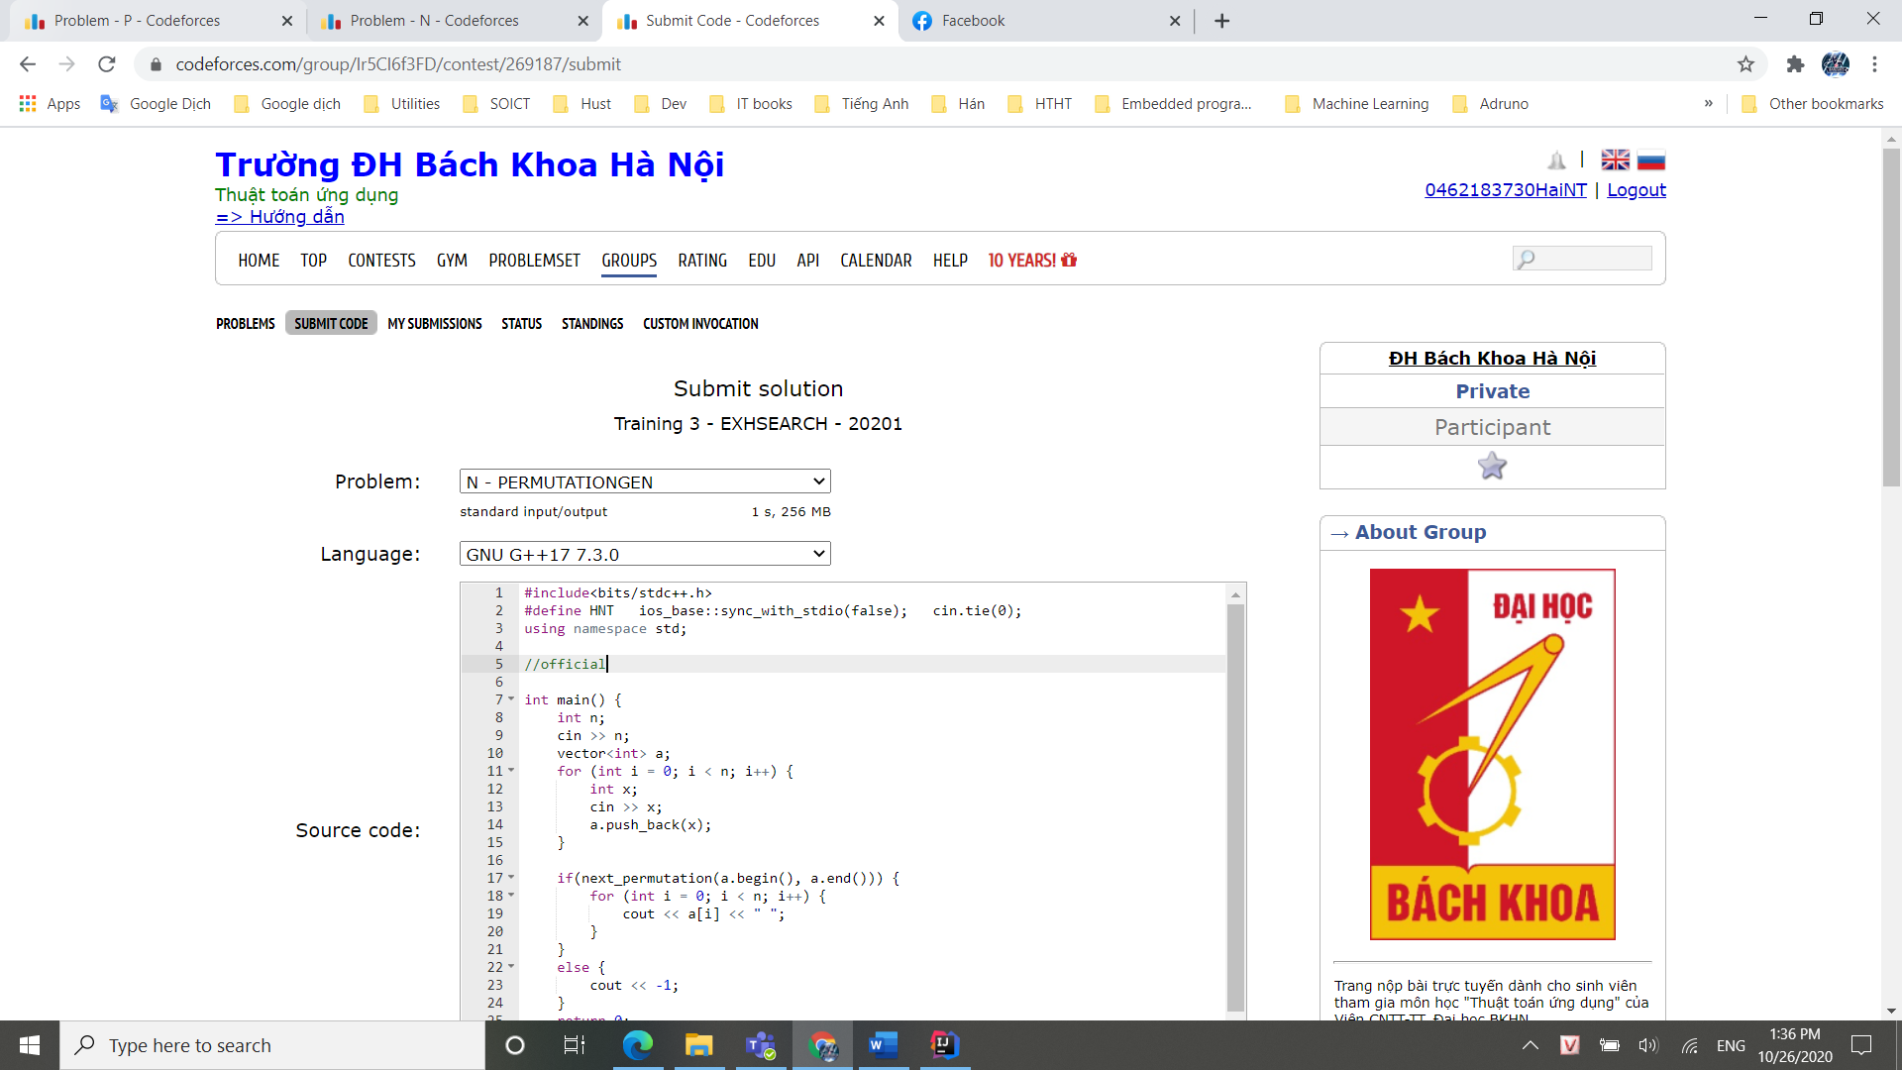

## **O – PERMUTATIONLIST**

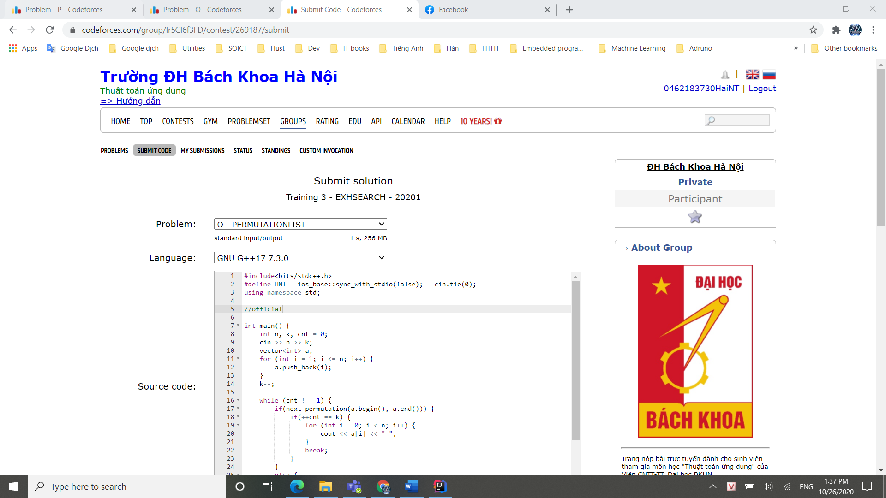

## **R – BINARYGEN**

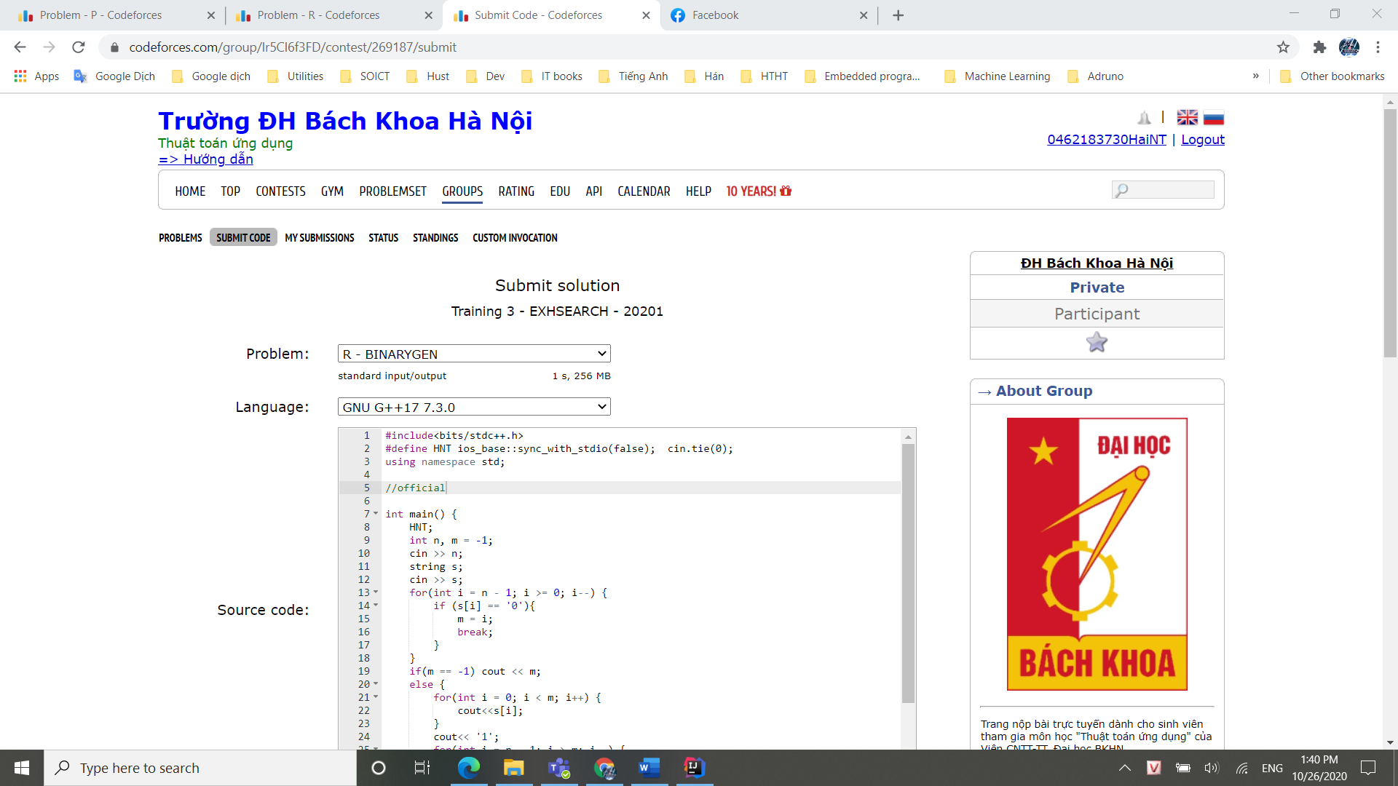

## **T – HOLLEY N QUEENS**

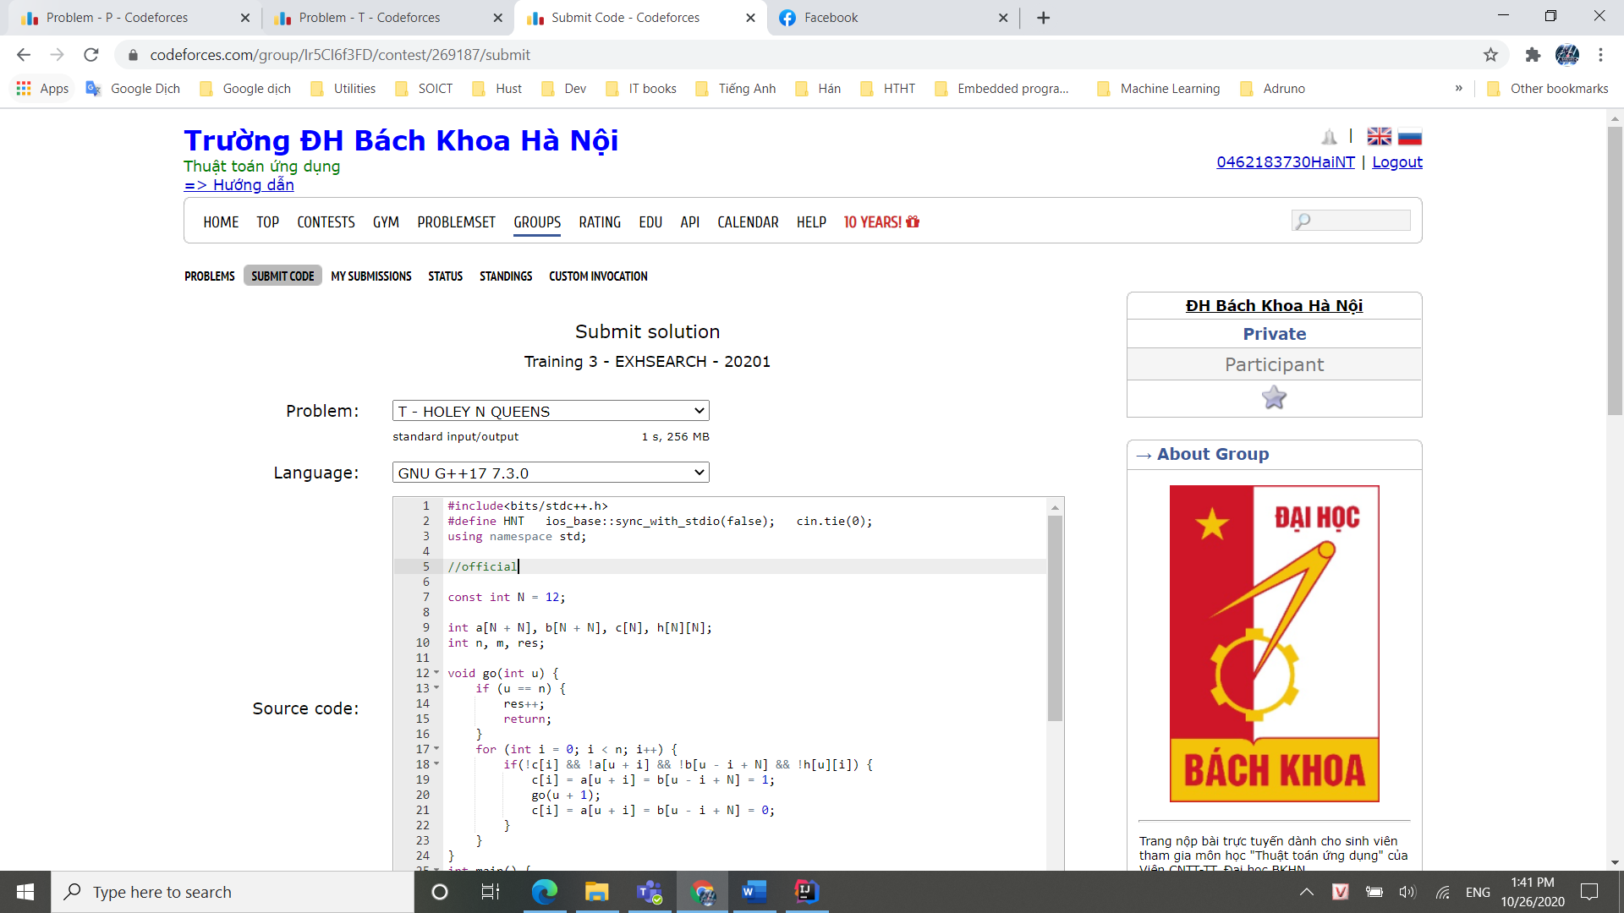

## **U – 05.NURSE**

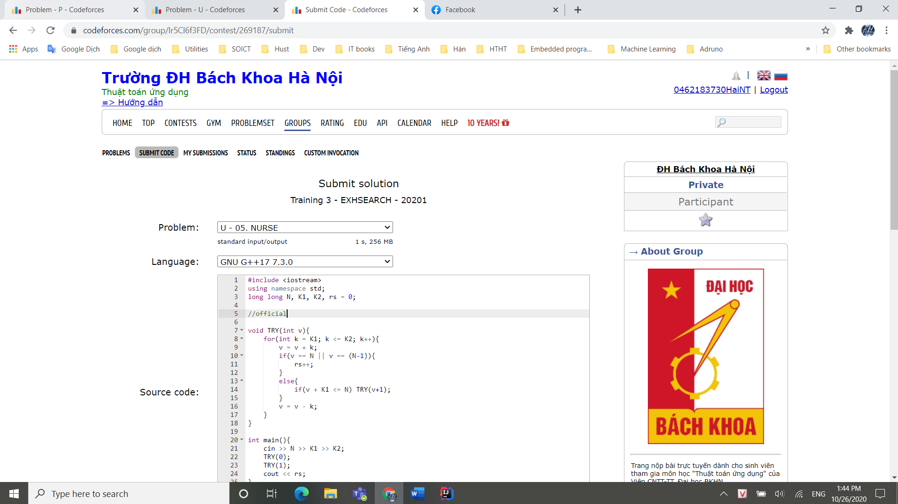

## **V – KPATH**

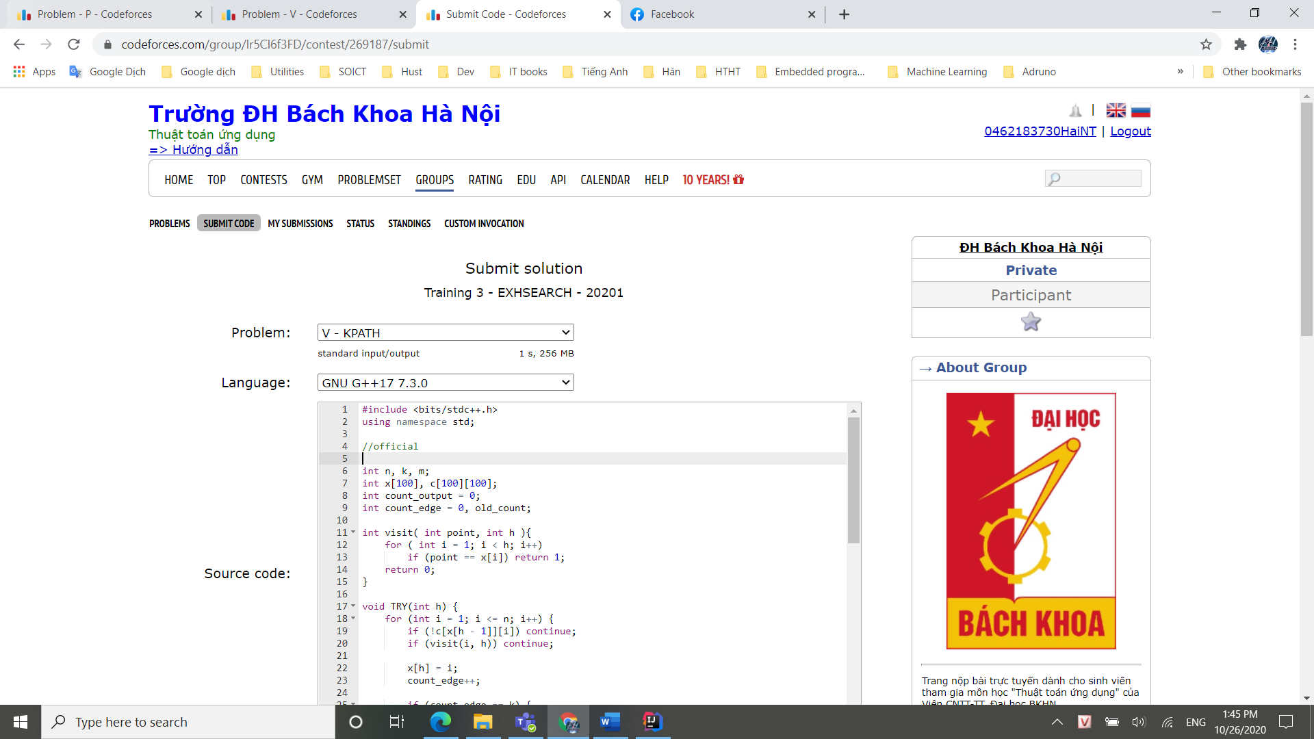

## **W – ROUTING**

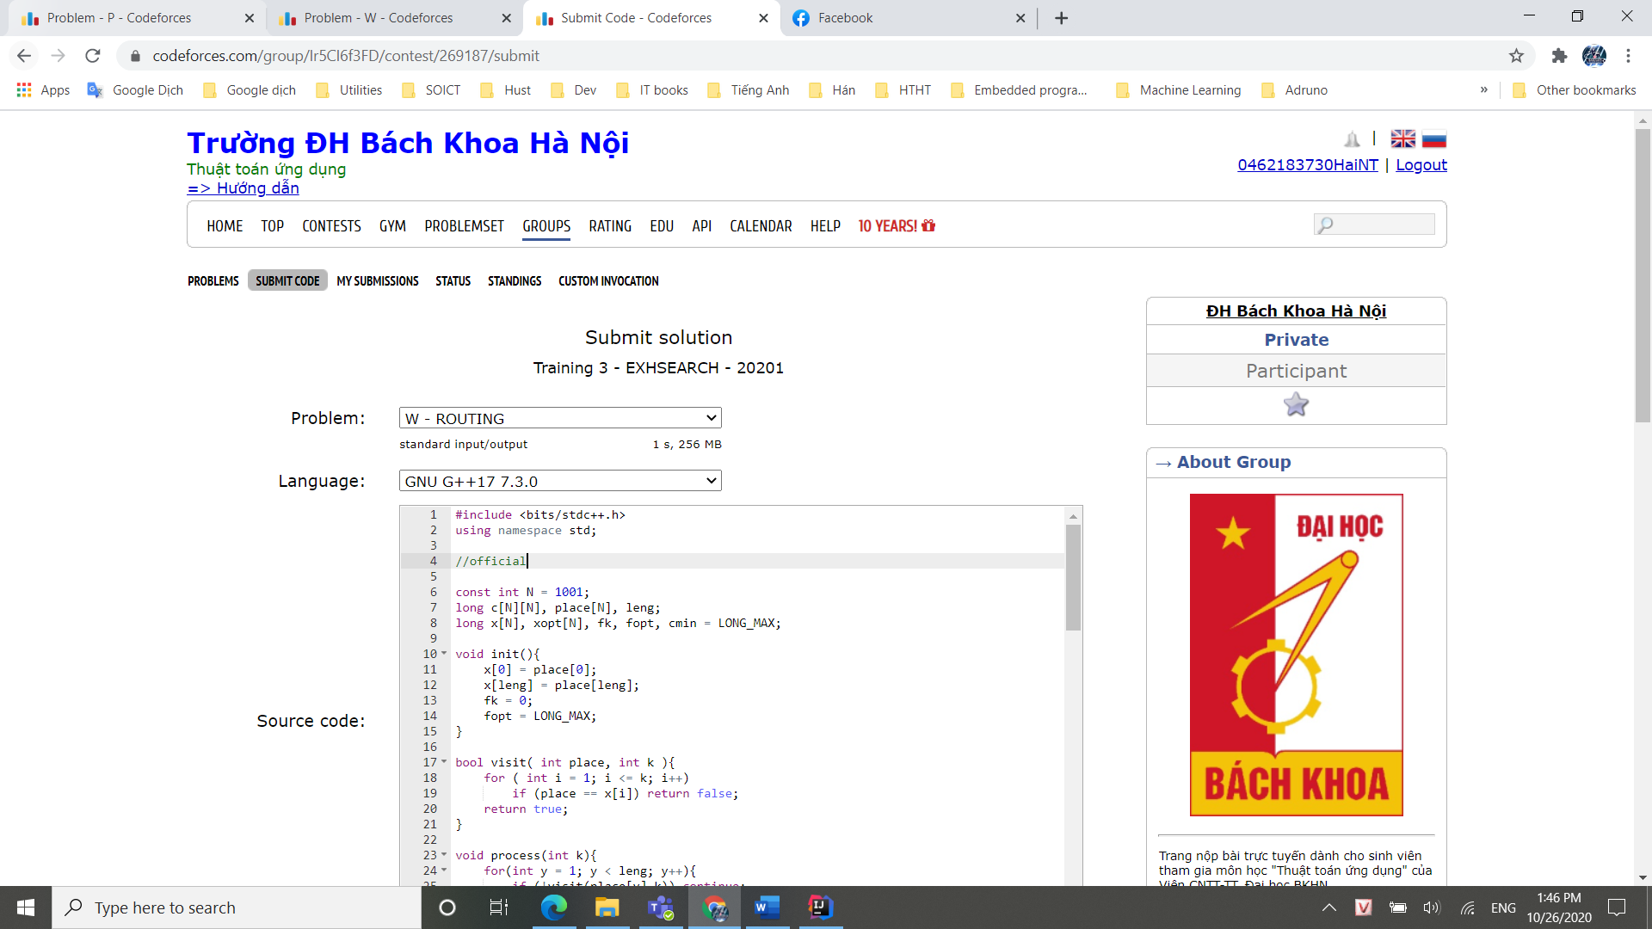

## **X – CNK RM**

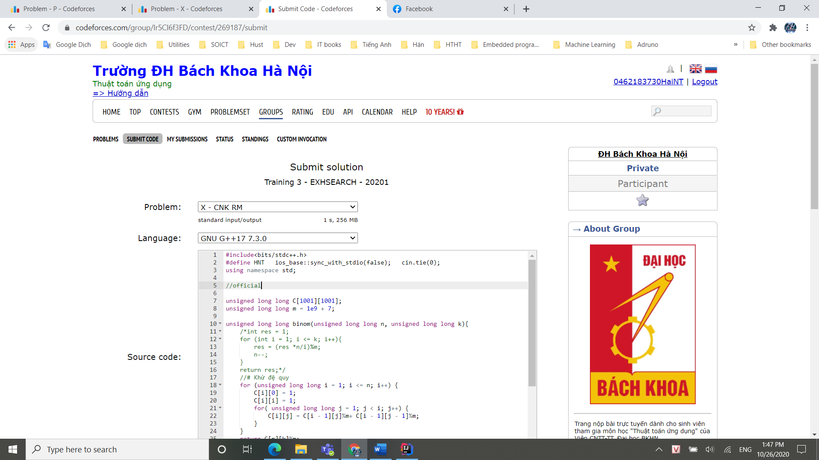

## **KẾT QUẢ TRAINING 3**

